**DataBase Connection Code**

**Problem Statement:**

For some scripts, we require data to be pulled from ehub DB and this data keeps changing. So after a script failed during execution, team used to validate and change the data as and when required manually.

**Solution:**

For the above mentioned problem, implemented DB connection as a part of the Framework. Given the DB URL and Query to be executed in the methods created, will execute and provide the results, which can be used further in our test case execution. This reduces the manually effort of changing data frequently.

**eHub DB Details available for SC:**

|  |  |  |  |
| --- | --- | --- | --- |
| **DB/Service Name** | **URL Name** | **Host** | **Port** |
| EHU1S | SITMember | va10dx05-scan2.wellpoint.com | 1525 |
| EHMBRS1U | UATMember | va10dx10v1-scan1.wellpoint.com | 1525 |
| EHPRDS1U | UATProducts | va10dx10v1-scan1.wellpoint.com | 1525 |
| EHCLMS1U | UATClaims | va10dx10v1-scan1.wellpoint.com | 1525 |

**Steps to follow:**

For example, Search Member in SC application by fetching the input from DB

1. Create a feature file

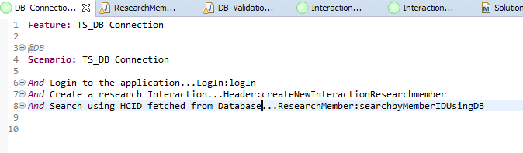

1. Create a method to fetch the Data from DB, this will return a Map of String which contains the column name and ArrayList contains the values of that column.
2. The “validateDBConnection” method is present in the DB_Validation class, where we should pass 2 parameters to fetch the data,
3. URL Name of the DB as mentioned in the Table
4. Query to be executed

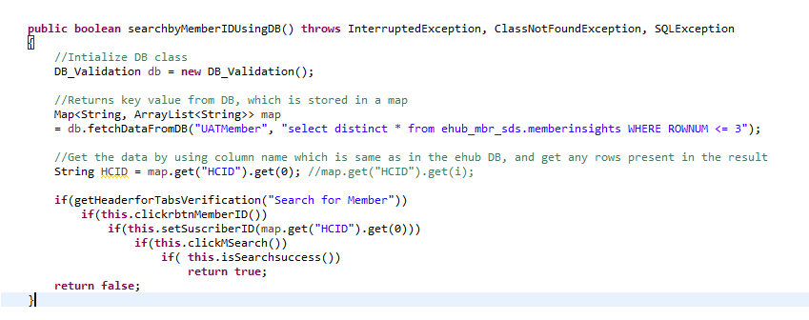

1. When the script is executed, the DB connection code will execute fetching the result, which is used in our code.